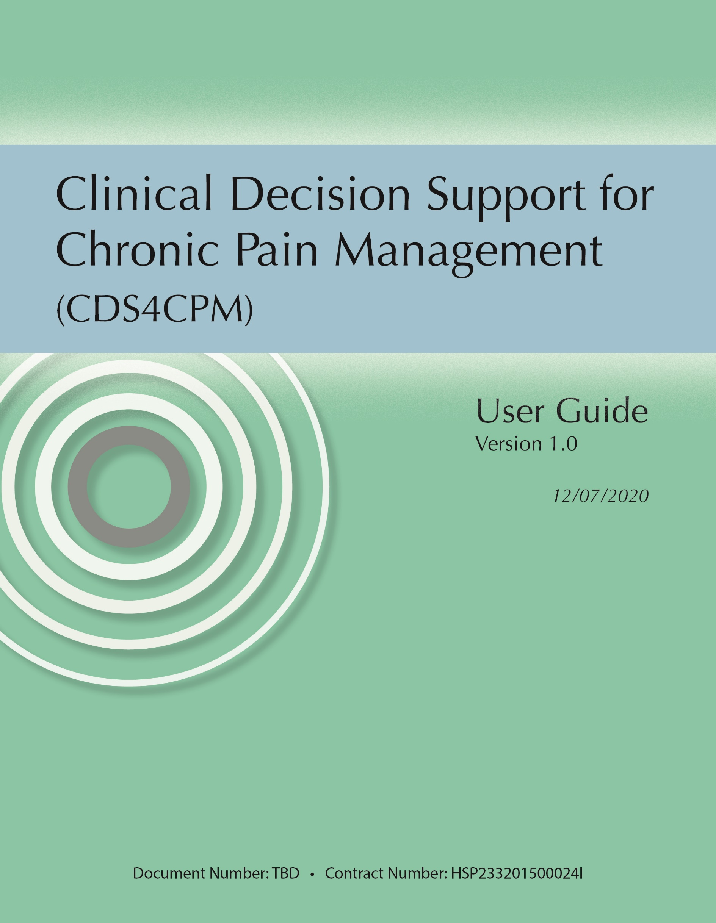

Table of Contents

Introduction 1

Project Tip Sheet 2

Purpose of This Guide 2

What are the benefits of this system? 2

Which patients will the project approach? 2

What will the project ask patients to do? 3

What will the project ask participating providers to do? 3

Contact Information 3

Tip Sheet for Clinic Staff 4

Purpose of This Tip Sheet 4

About Clinical Decision Support for Chronic Pain Management (CDS4CPM) 4

What are the benefits of these tools? 4

What is MyPAIN? 4

Who can use MyPAIN? 4

How is the information from MyPAIN used? 5

MyPAIN Navigation and Use 5

What are the steps in using MyPAIN? 5

How does the patient access MyPAIN? 6

How does the patient navigate MyPAIN? 6

Viewing Educational Resources 9

Rating the MyPAIN App 9

Reviewing and Submitting Responses 9

What’s next after I submit the MyPAIN responses? 11

Tip Sheet for Providers 12

Purpose of This Guide 12

About CDS4CPM **Error! Bookmark not defined.**

What are the benefits of this approach? 12

What is CDS4CPM? 12

PainManager Navigation and Use 13

Accessing the System 13

How to find PainManager 13

How to access any available content from MyPAIN 13

PainManager SDM Walkthrough 13

Navigating PainManager 13

PainManager Materials as Support for the SDM Encounter 16

Closing a PainManager Session and Next Steps 16

Recording the SDM Encounter in Epic 17

Information and Warning Notifications 17

Related Details or Tip Sheets 19

Introduction

This User Guide serves as a collection of resources intended to provide staff and clinicians at **[Site Name]** clinics with a general understanding of the CDS4CPM project and the goals of [’s implementation of the applications, as well as the ability to make use of the applications’ primary functions. The “Project Tip Sheet” introduces the concepts of MyPAIN and PainManager to clinic staff, briefly describing their objectives and benefits, and explains how patients and providers will participate in the pilot implementation. The “Tip Sheet for Clinic Staff” provides an introduction to the MyPAIN application for clinic staff and contains a step-by-step walkthrough that staff can use to assist patients who may face challenges in using the application. The “Tip Sheet for Providers” gives participating clinicians an introduction to the PainManager application, explaining the information they can expect to find and the sources of this information and how to navigate through the system. Across all included resources, contact information is provided for any users who wish to ask questions of the project sponsors and/or managers.

Project Tip Sheet

# Purpose of This Guide

This brief guide is to help orient [Site Name] staff to this quality improvement project aimed at improving the management of chronic pain using clinical decision support to support shared decision making.

## About Clinical Decision Support for Chronic Pain Management (CDS4CPM)

Clinical Decision Support for Chronic Pain Management (CDS4CPM) is a quality improvement project to develop, implement, and evaluate two clinical decision support tools for providers and patients. These tools will promote shared decision making for managing chronic pain:

1. A picture containing text, clipart

   Description automatically generated**MyPAIN** via [EHR Patient Portal] for patients
2. **PainManager** via [EHR Provider Portal] for providers

**[OPTIONAL RECRUITMENT STATEMENT**]

## What are the benefits of this system?

This system provides end-to-end support for shared decision making for CNCP management. It uses evidence from the Centers for Disease Control and Prevention for opioid management.

Together, MyPAIN and PainManager promote and support discussion between the patient and the provider on the effectiveness of existing treatments; the benefits and risks of specific intervention options; and the use of opioid, non-opioid, or nonpharmacologic treatments.

## Which patients will the project approach?

Patients with four common conditions are eligible: chronic low back pain, fibromyalgia, osteoarthritis of the hip, and osteoarthritis of the knee. Patients who may qualify will automatically be added to a registry [[SITE NAME] REGISTRY] for review by a provider, and providers will receive a Best Practice Advisory alert announcing that a new patient may qualify. Providers will be able to indicate that the patient is not a good candidate for the intervention or is a good candidate. If the latter is true, the provider will add the patient to the registry, so they can use MyPAIN in subsequent outpatient encounters. Adding the patient to the registry will send an invitation to the patient via an [EHR Patient Portal] message. Patients who are younger than age 18 are not eligible to participate.

## What will the project ask patients to do?

Eligible patients will get an email invitation to access MyPAIN. The study will ask patients to access MyPAIN through [EHR Patient Portal]. MyPAIN will ask them to answer questions about their pain and treatment preferences. Patients can also access educational resources in MyPAIN.

## What will the project ask participating providers to do?

We will ask providers to attend a brief training in [[SITE NAME] DETAILS ON DATES, TIMES, AND DURATION] and review tip sheets on how to use PainManager. [PROVIDE [SITE NAMES] DETAILS ON LOGISTICCS OF TRAINING SESSIONS AND MODALITY].

Then we will ask you to use PainManager for eligible patients between mid-January and April 2021 in your daily work. We will ask you to pre-clear patients for inclusion. We will ask that you provide feedback on PainManager using the survey link within the application as well.

We will also ask a subset of providers to take part in a 1-hour interview about their experiences with CDS4CPM.

# Contact Information

**Site Sponsors**

[Name, email, phone]

[Name, email, phone]

**Site Project Manager**

[Name, email, phone]

[Site Name] IRB approval number #[XXXXXXX].

**Document Last Updated:** [MM/DD/YYYY]

Tip Sheet for Clinic Staff

# Purpose of This Tip Sheet

This brief guide is for [Site Name] staff to help patients quickly access and navigate the MyPAIN application.

## About Clinical Decision Support for Chronic Pain Management (CDS4CPM)

Clinical Decision Support for Chronic Pain Management (CDS4CPM) is a quality improvement project to develop, implement, and evaluate two clinical decision support tools for providers and patients. These tools will promote shared decision making for managing chronic pain:

1. A picture containing text, clipart

   Description automatically generated**MyPAIN** via [EHR Patient Portal] for patients
2. **PainManager** via [EHR Provider Portal] for providers

## What are the benefits of these tools?

* Provides support for:
  + Patients living with chronic pain
  + Integration with [EHR Patient Portal]
  + Assessment of pain and treatment preferences
  + Providing educational content on SDM
* PainManager and MyPAIN work together to provide end-to-end support for shared decision making (SDM) for chronic pain management.
* This system collects patient-reported data and uses evidence from the Centers for Disease Control and Prevention for opioid management.
* Together, MyPAIN and PainManager promote and support discussion between the patient and the provider on
  + the efficacy of existing treatments,
  + the benefits and risks of specific intervention options,
  + and the use of opioid, non-opioid, or nonpharmacologic treatments when applicable.

## What is MyPAIN?

MyPAIN is a patient-facing application to gather chronic-pain related data and patient goals. The project team will identify and invite eligible patients via a [Site Name]-approved registry to enter their pain-related symptoms, goals, and preferences for providers to view during clinic visits.

Eligible patients will get an email invitation to access MyPAIN. Patients will use MyPAIN to respond to a questionnaire about their pain and treatment preferences. They will also be able to access educational content on SDM. Their physician will be able to review their responses and relevant pain-related data from [EHR Vendor Name] in PainManager at a visit.

## Who can use MyPAIN?

Those eligible to receive the MyPAIN app (just need MyChart and internet access, can be used in any preferred browser on any device) are adult patients 18 and older (those under 18 are not eligible) and who are diagnosed with four common chronic pain conditions:

|  |  |
| --- | --- |
| * Chronic low back pain * Fibromyalgia | Osteoarthritis of the hip  Osteoarthritis of the knee |

## How is the information from MyPAIN used?

When the patient submits their MyPAIN responses, their provider will get a notification indicating that the patient has responded to the questions (see also [PainManager tip sheet]).

# MyPAIN Navigation and Use

Following are instructions and screenshots to guide a patient through the use of MyPAIN from invitation to submission.

The following instructions demonstrate how the CDS4CPM tools will function when patients are selected for the intervention.

## What are the steps in using MyPAIN?

1. The patient receives a **MyPAIN invitation**.
2. The patient **launches MyPAIN** via [EHR Patient Portal].
3. The patient **responds to questions** about:
   1. pain location,
   2. pain intensity,
   3. pain interference,
   4. treatments (basic, mind-body, new, nontraditional, nonprescription, and prescription), and
   5. their treatment goals and barriers.
4. The patient **reviews the educational resources** provided to prepare for their upcoming visit with their provider.
5. The patient **indicates whether MyPAIN helped them prepare** for their visit and submits their final responses.
6. MyPAIN **provides the patient’s responses to their provider** to review before or during their visit.
7. The provider and patient **review the responses together** to develop a treatment plan during an SDM encounter.

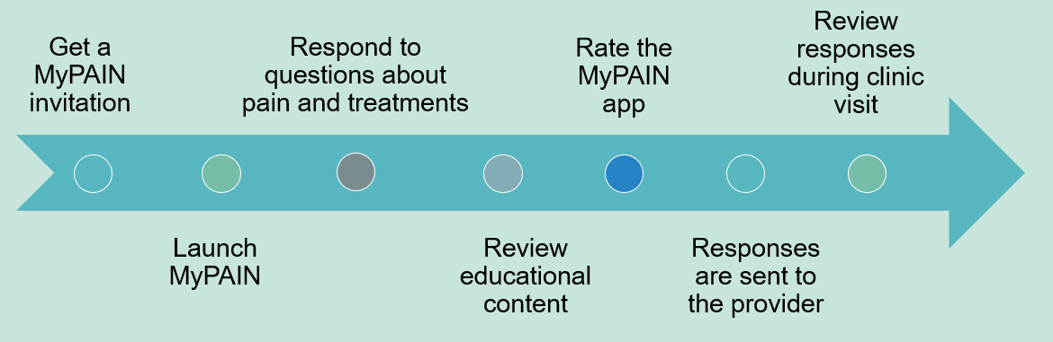

## How does the patient access MyPAIN?

1. Upon being invited to participate in an SDM visit with their provider, the patient will receive an invitation message in the MyChart inbox.
2. The patient will click on the invitation (NOTE: Example screen included in ***Figure 1***) to launch MyPAIN. The questionnaire will launch in the patient’s MyChart window inside the patient’s browser. NOTE: Example screen included in ***Figure 2***.

|  |  |
| --- | --- |
| Figure 1. MyPAIN Invitation | Figure 2. MyPAIN Upon Launch |
| [PROVIDE A [SITE NAME] EXAMPLE OF THIS] |  |

The patient will navigate sequentially through the app by clicking the “Next” button at the bottom of the screen. At the top right, a circle will indicate progress through MyPAIN. There is a back button at the top left of each screen. It is important that the user avoid their browser’s back button while using MyPAIN.

## How does the patient navigate MyPAIN?

*Answering questions about their pain and treatment preferences (no responses are required)*

Provide the following instructions to the patient:

1. Indicate where you have been experiencing pain in the last 7 days and the type of pain by clicking the button response options. (NOTE: Example screen included in ***Figure 3***.)
2. Indicate your pain intensity overall for the past 7 days by clicking the button response options. (NOTE: Example screen included in ***Figure 4***.)
3. Indicate your pain interference overall for the past 7 days by clicking the button response options. (NOTE: Example screen included in ***Figure 5***.)

|  |  |  |
| --- | --- | --- |
| Figure 3. | Figure 4. | Figure 5. |
|  |  |  |

1. Indicate treatments you have tried and how they worked. These are clickable button response options. (NOTE: Example screens are included in ***Figures 6*** through ***11***.)

|  |  |  |
| --- | --- | --- |
| Figure 6. | Figure 7. | Figure 8. |
|  |  |  |

|  |  |  |
| --- | --- | --- |
| Figure 9. | Figure 10. | Figure 11. |
|  |  |  |

1. Indicate your activity goals and barriers. These are open textbox response options with no set character limit. (NOTE: Example screens are included in ***Figures 12*** and ***13***.)

|  |  |
| --- | --- |
| Figure 12. | Figure 13. |
|  |  |

## Viewing Educational Resources

1. [Click to watch](https://www.theacpa.org/acpa-car-with-four-flat-tires/) a short video from the American Chronic Pain Association, “Car with Four Flat Tires.” This link will launch in the browser window with controls for the user to manage. (NOTE: Example screen included in ***Figure 14***.)
2. [Click to open](https://uspainfoundation.org/living-with-pain/) a website on living with pain by the U.S. Pain Foundation. This link will launch in a new browser window, and the user can navigate the site. (NOTE: Example screen included in ***Figure 15***.)

|  |  |
| --- | --- |
| Figure 14. | Figure 15. |
|  |  |

# Rating the MyPAIN App

1. Indicate whether the use of MyPAIN was helpful in preparing you for your upcoming visit with your provider. The first question has a clickable button response, and the second is an open text field with no character limit. (NOTE: Example screens are included in ***Figures 15*** and ***16***.)

## Reviewing and Submitting Responses

1. Review all your response options or navigate back to sections to make revisions, then use the submit button to submit your final responses (single scrolling page of text with navigation options and a submit button at the bottom). (NOTE: Example screen included in ***Figure 17***.)

|  |  |
| --- | --- |
| Figure 15. | Figure 16. |
|  |  |

|  |
| --- |
| Figure 17. |
|  |

## What’s next after patients submit their MyPAIN responses?

Once a patient has navigated through MyPAIN and entered the applicable information, they should **submit their responses**. Once the patient confirms that the responses have been submitted, they may log out of MyChart and close their browser window.

If the patient has entered data for any items in MyPAIN, the data are displayed in the “Shared Decision Making (patient-provided data)” tab of PainManager (see the MyPAIN tip sheet). That tab is set to open by default whenever MyPAIN data are available. PainManager will display the date when the patient submitted the data, their activity goals and barriers, their reported pain locations, and their pain intensity and pain interference in the last 7 days.

**For questions related to the CDS4CPM project, please feel free to contact the following:**

|  |  |
| --- | --- |
| CDS4CPM Site Sponsor  [Name of Site Sponsor]  [[Email](mailto:ckkao@medicine.bsd.uchicago.edu) Address of Site Sponsor] | CDS4CPM [Site Name] Project Manager  [Name of Project Manager] [Email Address of Project Manager] |

Please report bugs and technical issues via this [SITE NAME] survey.

**Document Last Updated:** [MM/DD/YYYY]

Tip Sheet for Providers

# Purpose of This Guide

This brief guide is intended to help participating providers quickly access and navigate the PainManager application to assist in shared decision making (SDM) sessions with patients suffering from chronic pain. Data in the system will be populated by the patients’ electronic health record, as well as patient-provided data from MyPAIN (in the form of an application-based questionnaire) about their pain.

## About Clinical Decision Support for Chronic Pain Management (CDS4CPM)

Clinical Decision Support for Chronic Pain Management (CDS4CPM) is a quality improvement project to develop, implement, and evaluate two clinical decision support tools for providers and patients. These tools will promote shared decision making for managing chronic pain:

1. A picture containing text, clipart

   Description automatically generated**MyPAIN** via [EHR Patient Portal] for patients
2. **PainManager** via [EHR Provider Portal] for providers

## What are the benefits of this approach?

* This system builds on existing, evidence-based CDS tools.
* PainManager and MyPAIN work together to provide end-to-end support for SDM for chronic pain management.
* Together, the tools promote and support:
  + discussion between the patient and the provider on the effectiveness of existing treatments,
  + the benefits and risks of specific intervention options,
  + and the use of opioid, non-opioid, or nonpharmacologic treatment when possible.

## What is CDS4CPM?

CDS4CPM is a system featuring provider- and patient-facing SDM applications being implemented in primary care clinics as identified by [Site Name].

This study is targeted to patients who have been added to the pain registry previously or specifically been excluded from the pain registry by the Health Maintenance modifiers. It is relevant to adults patients 18 and older (those under 18 are not eligible) with a previous diagnosis of the following four common chronic pain conditions:

|  |  |
| --- | --- |
| * Chronic low back pain * Fibromyalgia | Osteoarthritis of the hip  Osteoarthritis of the knee |

This pilot involves the selection of patients for participation via a [Site Name] registry. The following instructions demonstrate how the CDS4CPM tools will function when patients are selected for the intervention. When the patient submits MyPAIN data, providers will get an alert indicating that the data are present before to the upcoming SDM encounter.

# PainManager Navigation and Use

Following are instructions and screenshots to guide a provider through the use of PainManager.

## Accessing the System

If a patient responds to items in MyPAIN (see the [MyPAIN Clinic Tip Sheet]), those data will be available to a provider in PainManager.

## How to find PainManager

1. Providers will be able to launch the PainManager application using a link in [EHR Provider Portal]. [SITE NAME examples to be included below]
2. This link will open PainManager in a sidebar. [SITE NAME examples to be included below]

## How to access any available content from MyPAIN

Patients who may qualify will automatically be added to a Reporting Workbench Report for review by a provider, and providers will receive a Best Practice Advisory alert announcing that a new patient may qualify. Specific providers will be able to indicate that the patient is not a good candidate for intervention or is a good candidate. If the latter is true, the provider will add the patient to the registry, so they can use MyPain in subsequent outpatient encounters. Adding the patient to the registry will send an invitation to the patient via a [EHR Patient Portal] message.

If the patient enters data for any items in MyPAIN, the data are displayed in the “Shared Decision Making (patient-provided data)” tab of PainManager (see the following screenshots). That tab is set to open by default whenever MyPAIN data are available. PainManager will display the date when the patient submitted the data, their activity goals and barriers, their reported pain locations, and their pain intensity and pain interference in the last 7 days.

Providers will be notified of any new MyPAIN submissions via the [EHR Provider Portal] In Basket message function.

[Include [SITE NAME] examples highlighting the available content/patient data (e.g., message, etc.) within PainManager and where it can be found]

## PainManager SDM Walkthrough

The provider will be able to access patient responses submitted via MyPAIN to support SDM (see the following screenshots). If the MyPAIN data are present for a patient, this will be the default open tab in PainManager when the provider opens the application. If no MyPAIN data are present, the provider can still access data on the patient’s pain conditions, pertinent pain treatments, and rine drug screening history. The provider and patient can then review these data and responses together to develop a treatment plan during a clinic visit.

## Navigating PainManager

1. If the patient has entered data for any items in MyPAIN, the data are displayed in the “Shared Decision Making (patient-provided data)” tab of PainManager (see the following screenshots). That tab is set to open by default whenever MyPAIN data are available. PainManager will display the date when the patient submitted the data, their activity goals and barriers, their reported pain locations, and their pain intensity and pain interference in the last 7 days. NOTE: Example screen included in ***Figure 4***.

Figure 4.

1. The Pertinent Conditions section contains data on chronic pain conditions and on co-morbid conditions increasing risk when using opioids. Lookback is 12 months unless otherwise specified. NOTE: Example screen included in ***Figure 5***.

Figure 5.

1. The Current Pertinent Treatments tab contains data on active prescriptions including non-opioids and opioids, the date prescribed, and the sig. This section also includes a calculated morphine milligram equivalent (MME)/day at the individual prescription level and across all relevant opioid prescriptions. (Calculations should align with [EHR]’s morphine equivalent daily dose (MEDD) value or provide further details on any discrepancies.) Finally, patient-reported data from MyPAIN on treatments and their effectiveness are included as well. NOTE: Example screen included in ***Figure 6***.

Figure 6.

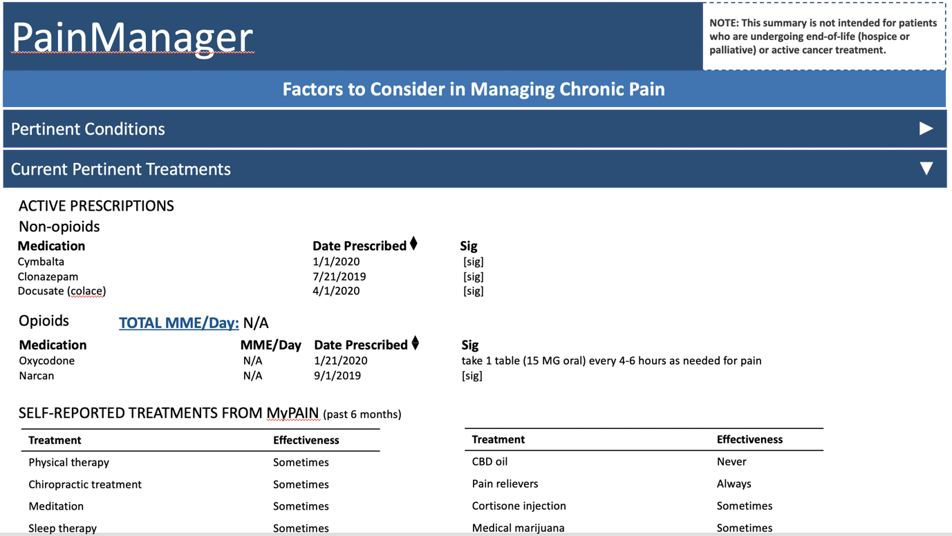

1. In the Urine Drug Screening section, a table with relevant results is provided. Details on the test, the test date, and the result are provided by most recent test farthest to the left. NOTE: Example screen included in ***Figure 7***.

Figure 7.

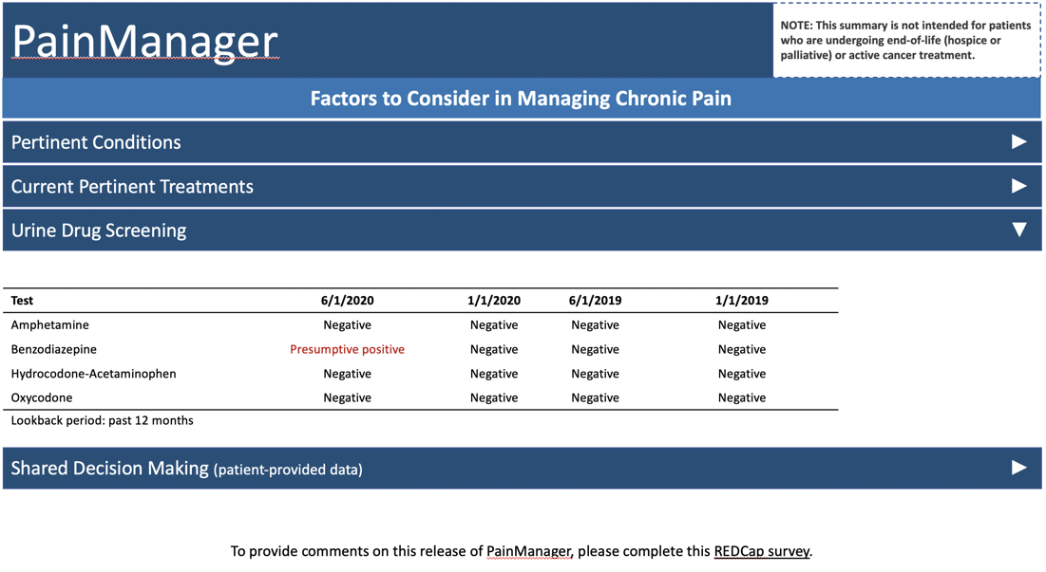

1. These data are intended to support SDM between the patient and the provider during an encounter to develop a chronic pain management plan that better incorporates patient goals and values. Results of the encounter should be stored in the patient chart using a SmartPhrase (further details are provided in “Recording the SDM Encounter in [EHR]”).
2. To support the pilot and gain feedback on the use of MyPAIN and PainManager, please note the link to the [SITE NAME] survey in the footer of PainManager. You can submit your comments and/or requests for changes, fixes, or enhancements using this survey. NOTE: Example screen included in ***Figure 8***.

Figure 8.

## PainManager Materials as Support for the SDM Encounter

Once a patient has navigated through MyPAIN and entered the applicable information, the patient should submit their responses. Once the patient confirms that the responses have been submitted, the patient may log out of MyChart and close their browser window.

If the patient has entered data for any items in MyPAIN, the data are displayed in the “Shared Decision Making (patient-provided data)” tab of PainManager (see the following screenshots). That tab is set to open by default whenever MyPAIN data are available. PainManager will display the date when the patient submitted the data, their activity goals and barriers, their reported pain locations, and their pain intensity and pain interference in the last 7 days.

## Closing a PainManager Session and Next Steps

Once a provider has reviewed patient information within PainManager, the provider should press submit to save any notes that may have been entered. Once the provider has confirmed that the information has been submitted, the provider can exit PainManager.

## Recording the SDM Encounter in [EHR]

Providers are encouraged to enter a [[SITE NAME] PRHASE OR SIMILAR]] to enter the following text within their note to indicate that a SDM session happened and that they viewed the PainManager data.

This patient shared information about their health history and goals for this visit via the MyPAIN application. The information was used during the visit as a shared decision-making tool to facilitate communication.

## Information and Warning Notifications

CDS logic to support chronic pain management focuses on implementing five recommendations from the Centers for Disease Control and Prevention (CDC) Opioid Guideline (<https://www.cdc.gov/mmwr/volumes/65/rr/rr6501e1.htm>), which include the following:

1. CDC Guideline #3: Before starting and periodically during opioid therapy, clinicians should discuss with patients known risks and realistic benefits of opioid therapy and patient and clinician responsibilities for managing therapy. NOTE: Example screen included in ***Figure 9***.

Figure 9.

1. CDC Guideline #5: When opioids are started, clinicians should prescribe the lowest effective dosage. Clinicians should use caution when prescribing opioids at any dosage, should carefully reassess evidence of individual benefits and risks when considering increasing dosage to ≥50 MME/day, and should avoid increasing dosage to ≥90 MME/day or carefully justify a decision to titrate dosage to ≥90 MME/day. NOTE: Example screen included in ***Figure 10***.

Figure 10.

1. CDC Guideline #8: Before starting and periodically during continuation of opioid therapy, clinicians should evaluate risk factors for opioid-related harms. Clinicians should incorporate into the management plan strategies to mitigate risk, including considering offering naloxone when factors that increase risk for opioid overdose, such as history of overdose, history of substance use disorder, higher opioid dosages (≥50 MME/day), or concurrent benzodiazepine use, are present. NOTE: Example screen included in ***Figure 11***.

Figure 11.

1. CDC Guideline #10: When prescribing opioids for chronic pain, clinicians should use urine drug testing before starting opioid therapy and consider urine drug testing at least annually to assess for prescribed medications as well as other controlled prescription drugs and illicit drugs. NOTE: Example screen included in ***Figure 12***.

Figure 12.

1. CDC Guideline #11: Clinicians should avoid prescribing opioid pain medication and benzodiazepines concurrently whenever possible. NOTE: Example screen included in ***Figure 13***.

Figure 13.

**For questions related to the CDS4CPM project, please feel free to contact the following:**

|  |  |
| --- | --- |
| **CDS4CPM Site Sponsor**  [Name of Site Sponsor] [[Ema](mailto:ckkao@medicine.bsd.uchicago.edu)il Address of Site Sponsor] | **CDS4CPM Project Manager**  [Name of Project Manager] [[Email](mailto:kimisha.cassidy@uchospitals.edu) Address of Project Manager] |

Please report bugs and technical issues via [[SITE NAME] survey].

**Document last updated:** [MM/DD/YYYY]

# Related Videos and Tip Sheets

* Personal pain goals (video): <https://www.youtube.com/watch?v=PGWQU_tYXfc&feature=youtu.be> or aboutmypain.website
* Preparing for Shared Decision Making (video): <https://youtu.be/pHekCnD47p0> or aboutmypain.website